CSE 581

**Lab 6: First Design Problem**

**Steps:**

1. Follow the steps described in class to create a DB design for the business problem described below[1]:

*Consider a hair salon business. The owner wants to keep track of the customers, their appointments, employees that perform the haircuts/services, products that the salon sells and of actual sales (for both haircuts and the products).*

**Deliverable:**

You will hand in a print out of your design (as a PDF file).

Your design should be normalized to 3rd normal form.

Your design should include the following:

* tables and columns
* primary and foreign keys
* relationships between tables
* nullability (whether the column is required or not)

Your design needs to be able to solve the business problem, while trying to respect the scope of the problem.

You may also submit a short explanation of non-obvious design choices or data assumptions you made[2].

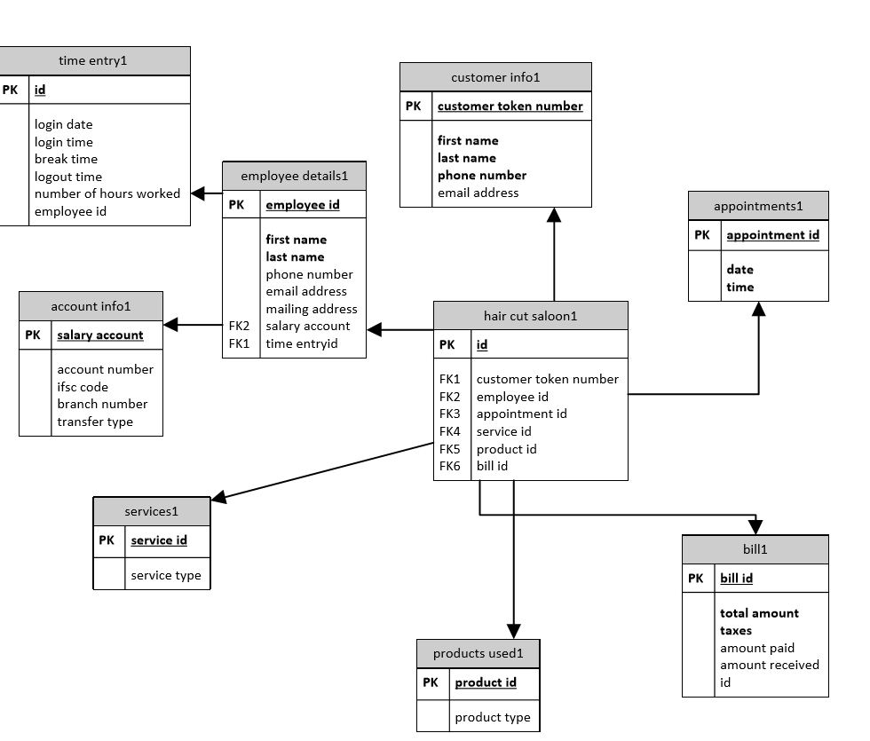

**My design explanation:** hair salon is a general place where everyone visits, since it is a necessity. We need to keep in track of all the business and transactions which goes in hair salon. This is required to avoid business conflicts.

**Hair saloon:** this table contains the general information. It contains the overall summary of the customer, which includes the customer token number, appointment time, employee id and the type of services customer received

**Customer info:** this table contains the information about the customer. The details which includes the customer name i.e, first and last name. and customer phone number and email address. So that we can contact the customer or update him with new styles

**Employee details:** this table includes the details of employee. Each employee is provided with an employee id. And we can track the employee information using that id.

**Time entry id:** this includes the login and log out time of employee. The break time taken and the total number of hours is calculated using the log in and log out time

**Salary account:** this table is under the employee details. This includes all the information required for transferring the monthly salary to the employer

**Appointment id:** this includes the check in and check out time of the customers. To avoid conflicts and to maintain data we need to keep track of appointment id

**Services:** this table includes the service type which is provided to the user. The service type considers of many things carried out in the saloon. Services includes

* haircut
* trimming
* face pack
* shaving
* waxing

**Products:** this includes the products which are used by the employee to provide services to the customer. The product type is mentioned to keep in track of all the quantity of products used. The products include

* scissors
* combs
* face creams
* hair gel
* shaving cream
* trimmer

**Bill:** this table includes all the amount which is costed for the services provided by the hair salon. This table includes the amount customer paid. The amount given back and also the id which is provided for customers

1.
2. Think about what data makes sense for the business problem and select the fields that make the most sense. Expected design scope is somewhere around 6-8 tables, 5 or so fields/table on average – your design does not need 100s of fields, but it does need to be able to function on its own.

   This is optional – best designs do not need this. No more than 1/3 of a page. Non obvious means I cannot figure it out from your design.